
Couch Potato
Lose Turn
Until
Yellow

Jumping
Jacks!!!
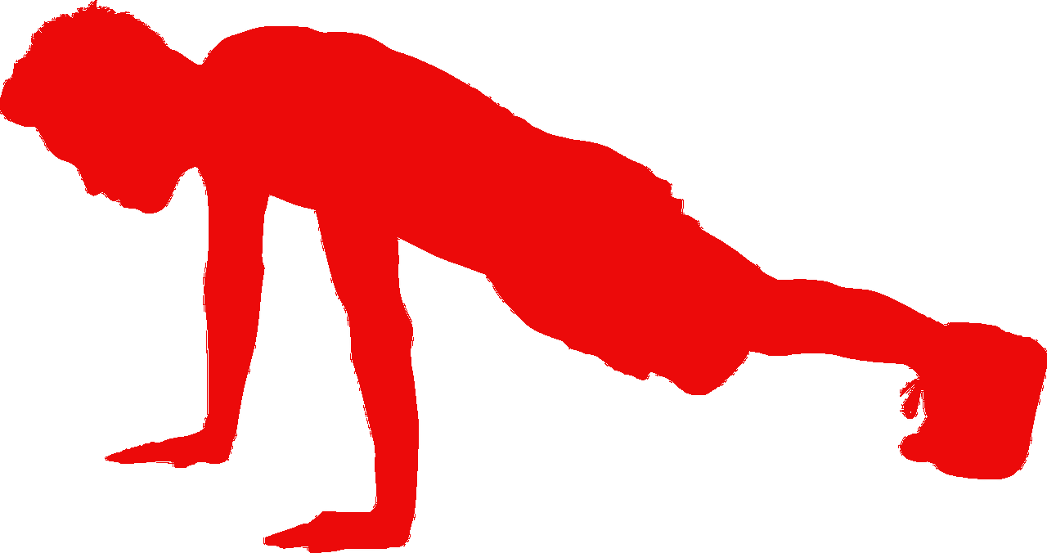
Pushups

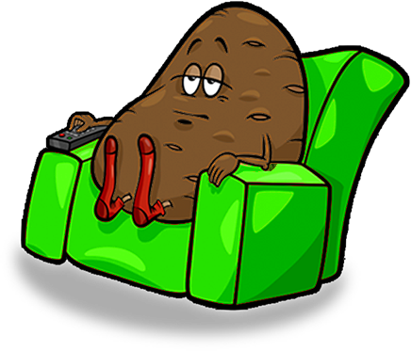

Couch Potato
Lose Turn
Until
Yellow

Situps



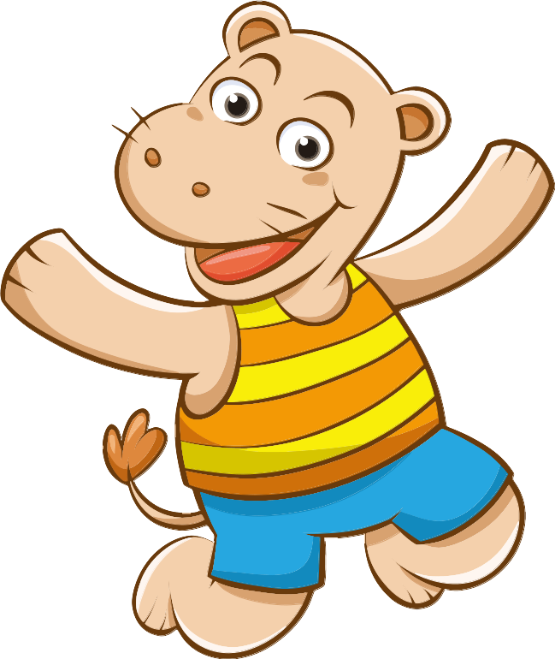
Pushups

Jump!

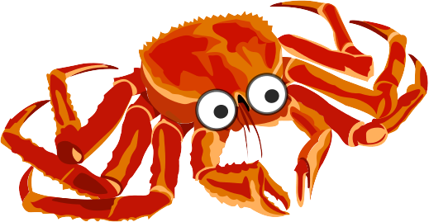
Crabwalk!

Pushups

Cut out this page into squares, put face down, each player gets one to move, do what circle where repetitions = age of player, youngest first




