Passive Solar Pool Heating System for Perote
Design and Model Construction

Parras Summer Program
HSU/UTC

Parras De la Fuente
Coahuila, México
Summer 2005

Heather Kuoppamaki
Rowan Steele
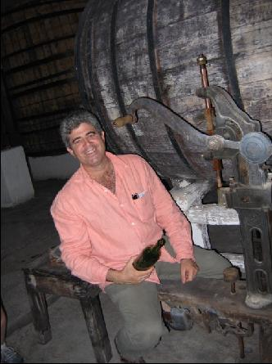

Table of Contents
Introduction 1
Description 1
Background 1
Constraints 2
Design 2
Solar collector 5
Frame 5
Heat exchanger 6
Construction 6
Solar collector housing 6
Housing Insulation 7
Solar collector copper tubing 7
Frame 8
Heat Exchanger 8
Connections 9
Maintenance 9
To-Do 9
Costs 9
Results and Discussion 11
Future Recommendations 14
Testing of the model 15
Photographs 16

Table of Ilustraciones
Ilustración 1: Birds eye view of the system. Six tubes of copper will pass through the solar collector. These tubes will join and move to the heat exchanger. Cold water will enter and leave the heat exchanger from the water supply. 3
Ilustración 2: Side view of the system design. The solar collector will be tilted to 30 degrees, the heat exchanger will be raised slightly above the solar collector to make the thermosiphon possible. 4
Ilustración 3: Inner heat exchanger container. 5

Table of Tablas
Tabla 1: Background information relevant to the project. 1
Tabla 2: Materials, sizes and locations and costs of materials used in construction. 10

Introduction
Parras de la Fuente is a town located in the high desert of southern Coahuila, Mexico. The town has many historic buildings and sites that date up to four hundred years old. One significant site on the western most edge of Parras is the Hotel Perote, which specializes in making sweet wines and Sotol. Several additions are currently being made to the hacienda, including a restaurant and an alberco. An alberco is a swimming pool which is supplied by water from a local natural source. The water source for this alberco is diverted from a previvous existing estanque, which receives its water supply from a lumbrero (water that comes out of a cave). The owner of Perote has expressed a desire to heat this new alberco with solar energy, which was the basis for the project at hand.

Description
The goal of this project was to produce a physical model to aid in designing a complete passive solar water heating system for the new alberco at Perote. The model is compromised of a solar collector and heat exchange unit; which will be used to extrapolate data in order to determine the feasibility of using solar energy for heating the entire alberco.

Until the full system is developed and constructed to heat the alberco, the single cell constructed will be used to heat water for a new bathroom and shower facility near the alberco.

Background
The general information regarding Parras and Perote are as follow (Tabla 1):
Tabla 1: Background information relevant to the project.
Elevation | 1,505 m
Longitude | 102°11'W
Latitude | 25º30’ N
Area of roof available | >200 m²
Temperature of water from the Lumbrero | 22º C
Flow rate of water into/out of alberco | 100 l/s
Chemical additions to water | Chlorine, pH, clarificador, alqucida
Pump size | ¼ hp

Constraints
Constraints with passive solar pool heating at this location are as follows:
- Reliable information on year round climate data including probability of freezing temperatures is difficult to find
- The owner wishes to have the pool open year-round
- Types of materials often used including wood are not as readably available
- Used materials in general are not as available in Parras as in other locations
- Limited access to tools
- Having a convenient, healthy secure workspace
- High summer temperatures in Parras limit the need for pool heating to mostly winter applications

Design
The initial phase in the project was to determine what type of solar system would be most suitable for the conditions at Perote. Through research of solar systems and materials available, a design was created to meet the needs of Perote project. The design chosen consists of a closed system-solar collector and heat exchanger, frame and connection tubing (Ilustración 1, Ilustración 2,Ilustración 3).

Ilustración 1: Birds eye view of the system. Six tubes of copper will pass through the solar collector. These tubes will join and move to the heat exchanger. Cold water will enter and leave the heat exchanger from the water supply.
Ilustración 2: Side view of the system design. The solar collector will be tilted to 30 degrees, the heat exchanger will be raised slightly above the solar collector to make the thermosiphon possible.

Cold water in
Hot water out
Hot antifreeze in
Cold antifreeze out
Ilustración 3: Inner heat exchanger container.

Solar collector
The general concept behind the solar collector is to heat up antifreeze in the copper tubing using solar energy. This process is aided by heavily insulated wooden housing. The wooden housing was insulated on the bottom as well as the sides. The copper tubing was elevated from the base of the housing to for more efficient heating of pipes. The pipes and housing were painted black to absorb more solar heat thus increasing the heat inside the collector. A sheet of glass was fitted to the top of the solar collector to allow solar radiation to enter the collector, but work as a barrier to retain the infrared radiation (heat energy) (Ilustración 1).

Frame
A wooden frame was constructed to tilt the solar collector to 30º above horizontal. This angle captures solar energy year round with an emphasis on winter. The collector was tilted slightly above the angle of the latitude for better collection in winter months, when the hot water will be most necessary (Ilustración 2). The height of the frame was determined using simple trigonometry. Which a 30º, and a hypotenuse of 8’2”, the back height of the frame was determined:

Sin(30º) = height
8.17 ft
This determined the back height of the frame to be a little over 4 feet high. Another set of legs will be placed half way up the collector, the distance calculated in a similar fashion.

Heat exchanger
The heat exchanger consisted of two flexible coils of copper tubing running in a parallel coil. In one coil, antifreeze runs top to bottom and in the other coil, water runs bottom to top. The idea behind this aspect of the system is that the heated antifreeze transfers its energy to the cooler water. As the temperature of the water rises, the cooler water entering the system below and the decreased density of the hot water force the water up. The antifreeze creates a similar cycle as the heated fluid leaving the collector cools and becomes
denser it moves down the coil. Using density differences for movement of fluids is called a thermosiphon and eliminates the need for a pump. The antifreeze will then return to the collector to be reheated, effectively closing the system (Ilustración 3).

Construction
Construction could be performed in various orders. The following is a description of the construction process followed for the model solar system.

Solar collector housing
The construction of the solar collector began with the wooden housing. A piece of plywood 8’1” x 4’1” was purchased for the bottom of the collector. An old wooden box was obtained and cut into pieces 5 1/4 inches wide to serve as the sides of the collector. These pieces were connected using L joints at the corners and to connect the sides to the bottom.

Two-one inch diameter holes were drilled in the sides of the collector to line up to where the copper tubing would enter and exit the system. Wood was used to insulate these areas because there was concern over the blue foam material melting.

Housing Insulation
A large piece of Styrofoam (8’ x 4’ and 2 inches thick) was purchased to insulate the bottom of the collector and small pieces of Styrofoam found in the trash were squeezed into the sides for increased insulation and a better fit. The insulation used for the sides was blue foam bricks that are usually used to buff walls before painting. Each brick was cut to a thickness of one inch and used to line the inside perimeter. Wood was then used to protect both forms of insulation (Styrofoam and foam bricks). A thin piece of plywood (8’1” x 4’1”) was place directly above the Styrofoam on the bottom of the collector. Pieces of plywood (2 – 4’ 1”x2”, 2 – 7’ 10.5”) were then used to line the foam bricks and secure the side insulation. These were attached with screws and L joints.

Solar collector copper tubing
Two sizes of copper piper were necessary to complete the requirements for the collector. This included six - ¾ inch pipes cut to 76” and two 30” one inch pipes. Both one-inch pipes were cut into 5 equal 6” sections and connected with T joints with a 90º connect at one end. The one-inch segments were made first with special attention align all the T’s and 90 in the same orientation. These one-inch diameter pipes then provided “book ends” for the 3/4” pipe to run between (Ilustración 1).

It should be noted that one of the 76” segments of ¾: pipe was significantly shorter because it was the remainder of two six-meter long lengths purchased from a hardware store. These segments were simply soldered together with a ¾” couple. We don’t anticipate there will be any decreased efficiency from this section of pipe.

All the pipes were sweat soldered to make permanent connections and to ensure that the joints were watertight. Once the entire copper system was constructed, it was painted black and pressure tested with water for leaks. One small hole was observed and addressed.

The copper system was put into the collector, with the inlets and outlets exiting the housing through the one-inch holes punched through the sides. Threaded couples where then soldered on to these exiting pipes while in the collector, because they were larger than the exit holes.

Frame
The frame was built to tilt the solar collector at a 30º angle. The frame was built from wood which was varnished to protect it from the elements. The frame consists of two wood planks serving as “legs”. The back support is two legs 6.5” x 1.5” and 3’ 7” high at teh tallest point. A piece of wood 1” wide connects these two legs. A second set of legs was placed half way down the collector. These legs were constructed out of two 2” x 3” pieces of wood 24” high at the tallest point. These legs were connected using a similar piece of wood as was used to connect the back legs.

Heat Exchanger
The heat exchanger was constructed from a blue plastic container obtained at a recyclable material collection area. 13.5 meters of flexible copper pipes (size media) was needed to provide a way to channel the water and antifreeze through the heat exchanger. The 13.5 meters was cut in half, and connectors were soldered to each end to attach 3/4” PVC tubes to the smaller flexible copper pipes. Two holes were punched in the bottom of the blue tub and another two towards the top. These provided a means for the water and antifreeze to move in and out of the heat exchanger.

The PVC attachments were made inside the exchanger (blue tub) itself for two reasons. First and foremost, it was thought that copper pipe would conduct enough heat to damage the plastic container while losing efficiency. Secondly, it provided a means for creating a better watertight seal because this container was filled with water.

The blue container was be placed in a larger, metal barrel that was obtained from the same recyclable material area. Styrofoam and sawdust/wood chips were placed in the space between the blue container and the larger barrel to provide insulation. The metal barrel had holes welded in it for the pipes to exit. These holes were insulated but not made water tight because it was not necessary.

Connections
Connections from the collector to the heat exchanger (and back) were be made with ¾” PVC piping. This was for cost reasons and to reduce the amount of energy conducted away from the heated antifreeze. Similarly, PVC pipes were attached to connect the inlet and outlet for the water. Both will connect at the heat exchanger. These connections were installed after the system was placed on the roof at Perote.

Maintenance
As important as the construction of the solar collector is the future maintenance. Since the solar collector is on the roof, it is easy for forget about. Regular maintenance will increase the life span and effeciencies of the solar collector. It is recommended that at least four times per year maintenance is performed at the minimum of a visual inspection. Maintenance should include checking of connections and water tight seals. Re-soldering of connections if leaks are spotted will be extremely important. If water is getting in the collector, it is recommended that a drain is added to the lowest corner fo the collector which can be plugged up to maintain heat in the collector. Re-painting as the paint wears off will be important in maintaining efficiencies in the system. Repairing/replacing pipes as they get weak is also important. Occasional visual inspection inside the heat exchanger for leaks in the flexible tubing will be important as well.

To-Do
Unfortunately, time did not allow us to completely finish installing the solar collector. We plan on doing as much intallation as possible and leaving minor details to the owner of Perote. These details will include making the connection to the bathroom and adding antifreeze into the system. How and where to perform these will be clearly marked on the system.

Costs
Costs were reduced whenever possible by using used or discarded materials. Most materials were purchased new because of availability or in the interests of lifespan and durability (Tabla 2).
Tabla 2: Materials, sizes and locations and costs of materials used in construction.
Material | Size | Purchased* | Cost (Pesos)
Collector sides (used wooden box) | 5 ¼” | 3 | 15
Collector bottom (plywood) | 8’1”x4’1” | 1 | 155
Top pipe (30”) | 1“ | 1 | 148
Parallel pipe diameter (44’) | ¾“ | 1 | 365
Insulation bottom (Styrofoam) | 8’x4’ | 1 | 120
Insulation sides x 9 (blue foam bricks) | N/A | 3 | 90
Glass supporter (wood) | 3’ 10”x1 5/6“ | 1 | Free
T connectors x 10 | 1” | 2 | 335
90º connectors x 2 | 1” | 2 | 26
Reducers x 12 | 1” – ¾” | 2 | 63
Solder x 2 | N/A | 1 | 62
Flux | N/A | 1 | 20
Torch/gas | N/A | 1 | 242
Matte Spray paint x 4 | N/A | 1 | 100
Frame (wood) | 6.5”x1.5” & 2”x3” | 1 | 117
Heat exchanger flexible copper tubing | 3/8 inch | 2 | 405
Heat exchanger inside container (Blue plastic tub) | N/A | 4 | 30
Heat exchanger outside container (Old petroleum container) | N/A | 4 | 70
Heat exchanger inside insulation (water) | N/A | -- | Free
Heat exchanger outside insulation (Styrofoam, wood chips, sawdust) | N/A | -- | Free
Top of collector (glass) | 8’ ¾”x4’ ¼” | 5 | 700
Total | --- |  | 3063
* 1 – Materiales Para Construction El Roble, 5 de Mayo No. 1A
2 – Materiales Para Construction “Lopez” Ramos Arizpe No. 279 Bis.
3 – Flea Market
4 – Recycling Center
5 – Glass store

Results and Discussion
Unfortunately, no results will be obtained during this summers project. Hopefully, the owner will be interested in hooking up hot water for the shower and bathroom near the alberco, and it will provided sufficient heat.

While there are many aspects of this project that are appropriate to the Parras region, some of the materials and processes used to create this system could be improved when adapting the model to the full array. The obvious obstacle to this technology being appropriate is the total cost to construct. Many of the materials were impossible to locate used or discarded, and others were simply above reasonable price. Technologies can never truly be appropriate if the economics prohibit the availability to the masses. While the costs of this project might be inflated because the lack of local resource knowledge and possibly several community members seeing an easy opportunity to take advantage of gringos with privilege, this type of system is not affordable to most people in this region.

One reason that this project was so expensive was due to the need for a heat-exchanging unit. This was a serious dilemma during the designing of the system. Without a heat exchanger, the system would not need antifreeze, flexible copper, a significant portion of the PVC, or either of the large containers. In addition, having an open system with the alberco water flowing directly through the collector is much more efficient than transferring heat to the pool water. The problem with not using a heat exchanger is that it was extremely difficult to get reliable temperature information for this area. Since water expands when it gets cold, if the collector contains water around zero degrees Celsius, there is a good chance that the copper pipes could burst or at least compromise its durability. Some locals declared that it snows every five years, while others suggested it was more probable once every 10 years. With either scenario, it was determined that it is in the best interest of the system if the extra precautions are taken to protect the collector. In many instances of solar pool system the system simply is not used during the winter season; thus solving this dilemma. This system is being designed specifically for winter swimming.

One assumption that is being made is that there will be sufficient solar inputs during the winter period when the system will need to be functioning greatest. Information obtained from the community suggests that solar isolation shouldn’t be an issue; there should be ample sun in the winter. Testing of the solar collector during winter months and obtaining more reliable climate data should be done prior to full construction.

The least appropriate aspect of this project is the fact Styrofoam was purchased to provide insulation for the bottom of the collector. This is especially disgusting considering that it is a material found in abundance in Parras. While a considerable amount of Styrofoam was collected to provide insulation in the heat exchanger, any attempt at creating an array should consider other cheap, abundant, local resources. One suggestion would be using lechugia (a local fiber with multiple uses), but that would raise the issue of durability and its ability to resist the high temperatures in the collector.

The heat inside the collector was actually a difficult aspect to address even with the non-biodegradable, store-bought materials used for insulation. Wood was used in several places to protect from direct contact with the hot copper pipes. Most notably, wood was placed at the points where the tubing enters and exits the collector. In addition, the blue foam is shielded from the copper by a strip of wood that also provides a means of support and containment to the insulation. It also serves as the support for the glass. The plywood covering the Styrofoam not only protects, but it allows for a black surface and a rigid structure to support the copper pipes. Tests performed showed that the Styrofoam could not hold up when in contact with hot objects nor could it hold up to spray paint.

Similar reasoning was used when creating the heat exchanger system. It was determined that if copper were in contact with the blue container, it would jeopardize the sustainability and the watertight seal. To combat this, the copper was connected to PVC while still in the container. PVC then leaves the heat exchanger because it will conduct significantly less heat away from the hot antifreeze and water. In addition, a broken tile was placed at the bottom of the blue container to provide insulation and lift the copper tubing off of the blue plastic.

Several important decisions were made while designing the copper piping structure. First was to choose between connecting the pipes in series or parallel. This is always a trade-off, as parallel has the ability to heat a greater amount of water at once, but pipes in series can get water to a higher temperature. The primary reason parallel was chosen was for a swimming pool in this desert environment, quantity is significantly more important than quality. More water heated is more important that heating the water hotter. For most of the year there will not be a need for extremely hot water as the spring, summer and fall temperatures in this area are somewhere between comfortable and sweltering.

The reasoning behind the two different sizes of copper in the collector was to facilitate more water at once. Since there are six, 76” tubes at ¾” diameter, more capacity was needed as water enters and leaves the collector. This will increase the velocity slightly, as water moves through the ¾” tubes, but it is anticipated to move it slow enough for the antifreeze to receive sufficient heating.

There are two general strategies used when painting the inside of a collector. Painting the copper black to increase total energy absorption and overall collector temperature. Or, painting the copper black and the inside white to help reflect radiation to the pipes itself. This method keeps collector temps slightly lower, but should get the copper sufficiently hot. The method chosen for this project was to paint everything black. The main reason behind this decision was that since we were hiding/protecting the white Styrofoam, it was easier to paint the wood black, since that color paint had already been purchased.

The original size of the collector was going to be 8’ x 5’, because it followed closely to the Fibonacci Ratio. But, it was discovered that size of wood was highly less available than the 8’ x 4’ used. It was determined that this size would be sufficient for the demands of the project.

Another important decision encountered in the design aspect of this project was to determine if the collector needed to be glazed (covered with glass). For a project where it’s more important to have large amounts of warm water—like an alberco—as opposed to extremely hot flows, often it is easier and cheaper to construct without glass. But, because this system is designed primarily for winter use, glass was determined to be practical. In addition, having a glass covering greatly helps the ease of waterproofing. Also, glazing the collector increases the chances that the system will be used for the bathroom/shower until the effort is taken to develop the array.

There were several significant problems encountered during this project. One of the largest was that the walls of the collector should have been at least an inch or two higher. Since they were constructed at 5 ¼”, it limited the amount of insulation on the bottom and the height the copper system could be elevated. If it could have been elevated another inch, it would have increased the efficiency.

Another problem was the fact that it is extremely difficult to get a huge system like this on the roof of a hotel. But, it was not practical for the system to be built at Perote, so this was simply a constraint that needed to be adapted to. Unfortunately, the space provided at Universidad Technologia de Coahuila (UTC) for construction was not secure, as vital tools and materials were stolen during the middle of construction. This not only added time and effort, but also considerable funds, as tools, supplies and materials needed to be replaced.

Future Recommendations
In order to make this system feasible for heating the alberco at Perote, future construction will need to be performed. The model built summer 2005 should be used as a test for determining what construction should consist of. Additional solar collectors and a larger heat exchanger will need to be built to meet the needs of the alberco. Testing and interpolation of results should be performed on the model to determine the future system. As a minimum, the following testing is recommended:

Testing of the model
Testing should be done seasonally. It is important to monitor the temperature differences entering and leaving the solar collector. This information will determine if the collectors need to be in series or parallel. Solar collectors in series will allow water to be heated to a higher temperature, but will not heat large quantities of water.

The temperature of the water and antifreeze entering and leaving the heat exchanger should also be tested. This will aid in determining if a larger heat exchanger is needed for the system. If the temperature of the antifreeze does not decrease significantly it is recommended that more coils of flexible copper be added to the system to allow for greater heat exchange.

The flow rate of the antifreeze and water through the system should be calculated as well. If more flow rate is needed, then the solar collectors should be added in parallel. Solar collectors in parallel will not allow for increased temperature gains.

Photographs
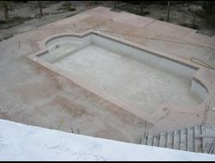  The alberco (pool) | 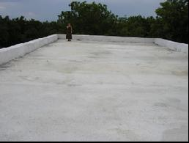  The roof where the solar system will be installed
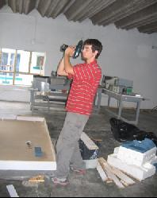  Making the housing | 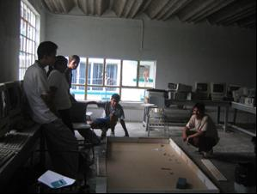  Getting by with a little (ok a lot) of help from our friends
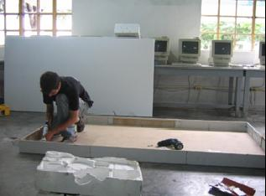Silicon addition for water/heat proofing | 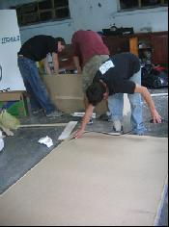  Cleaning up the housing
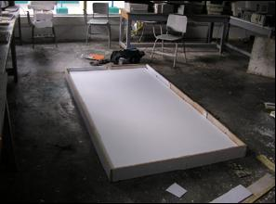  For bottom insulation we purchased a sheet of Styrofoam | 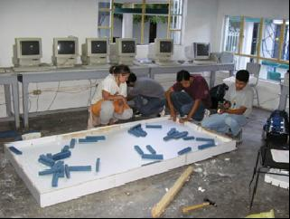More help from our friends to get the side insulation as tight as possible
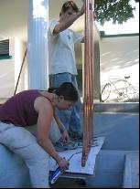  Soldering the collector tubing | 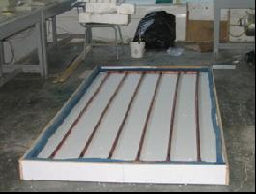  The solar collector construction mostly done
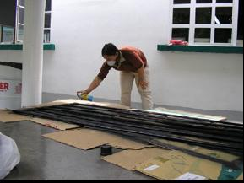  Painting the tubing black | 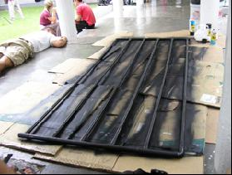  Spray paint is toxic
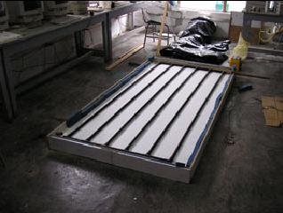Black tubing, white insulation | 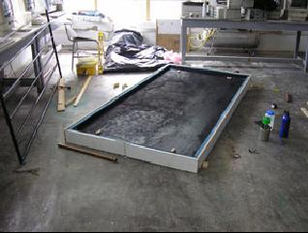Black wood
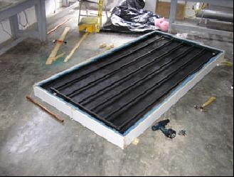Putting it together | 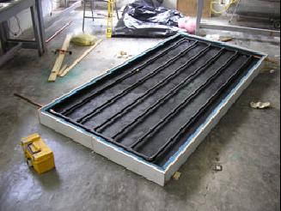More tubing
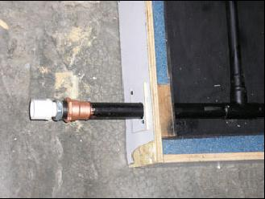Connections for the PVC piping | 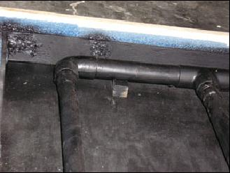Elevating the tubing in the collector
Inner heat exchanger chamber | 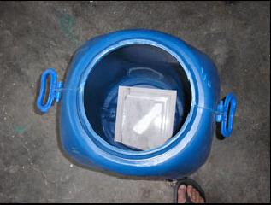  Tile to protect the tub from the hot coils
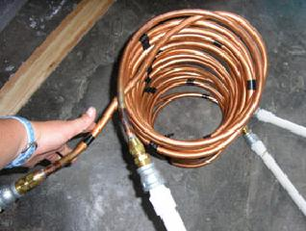  Parallel coils | 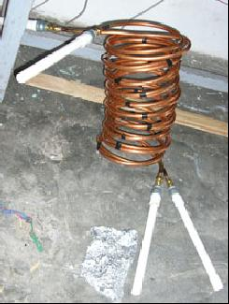  With connectors to PVC piping
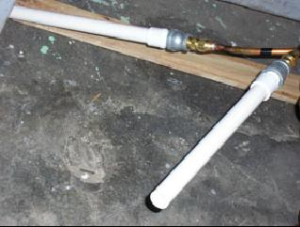
The connectors which will go through the exchanger walls

